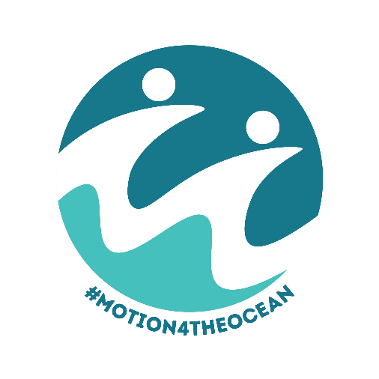
Motion for the Ocean (Inland Council, England)

The Local Government Ocean Recovery Declaration
Dr Pamela Buchan¹, Emily Cunningham² and Nicola Bridge³
A model motion to help local authorities play their part in
realising a clean, healthy and productive ocean and all of
the direct economic, health and wellbeing benefits it will bring
What is the Motion for the Ocean?
The Motion for the Ocean has been created to enable local authorities to play their part in realising a clean, healthy and productive ocean and all of the direct economic, health and wellbeing benefits it will bring. The #Motion4TheOcean is a blueprint for local action, developed by leading ocean experts Dr Pamela Buchan, Emily Cunningham and Nicola Bridge together with inland Councillors and Council Officers. It is non-partisan.
Councils of all tiers in England and Wales, along with the Local Government Association, have declared an urgent need for ocean recovery using a locally adapted Motion for the Ocean as can be seen on the dedicated webpage: Motion for the Ocean (see Appendix I). The majority of these are coastal, estuarine or maritime councils; however, the responsibility for ocean action lies equally with inland councils.
Why is it important for an inland council for pass a Motion for the Ocean?
No matter where we live in the UK, we are never more than 70 miles from the ocean. We all benefit from our ocean through the air we breathe, the food we eat, and the way our ocean regulates the climate. We all impact our ocean not only if we visit the coast but every day through our consumer choices, what we put down the drain, the litter and pollution that flows into our rivers, and the carbon emissions we produce. Our local stream or river is our direct link to the ocean.
The evidence is clear that our ocean is in a state of emergency and that this impacts us all, no matter where we live. The burden of taking care of our ocean falls to communities at the coast; but they are at the end of the line, receiving pollution and problems from inland communities. Inland councils have an essential role to play in recovering the health of our ocean through increasing awareness of how local actions can affect the ocean and by acting as responsible custodians of the rivers, streams and waterways that run through their area on their way to the sea.
A Model Motion for the Ocean for Inland Councils
We have developed a Model Motion for the Ocean for inland councils which should be considered as a template to be adapted to local circumstances. We encourage local councils to adapt the pledges and wording, with the caveat that the ambition must not be reduced. We are happy to support in this process.
For any support, please contact: Pamela | Emily | Nicola

Model ‘Motion for the Ocean’ for Inland Local Authorities

This Council declares an urgent need for Ocean Recovery.
The people of [AREA] benefit from our ocean through the air we breathe, the food we eat, and the way our ocean regulates the climate. We all impact our ocean not only if we visit the coast, but every day through what we put down the drain, the litter and pollution that flows into our rivers, through our seafood and consumer choices, and with the carbon emissions we produce. The River [NAME] is a key feature of our area and is our direct link to the ocean.
The burden of taking care of our ocean often falls to communities at the coast; but they are at the end of the line, receiving pollution and problems from inland communities like ours, and are on the frontline of the impacts of climate change. We know that many of our citizens are concerned about the future of our ocean.
[NAME] Council recognises that we have an essential role to play in recovering the health of our ocean through increasing awareness of how local actions can affect the ocean and by acting as responsible custodians of the rivers, streams and waterways that run through our area on their way to the sea.

This Council pledges to:
- Report to Full Council within [12] months on the actions and projects that will contribute to the recovery of the River [main local river] and its tributaries and the nature and wildlife that they support within the [authority area]. Tributaries are included in subsequent pledges even if not directly stated.

- Embed protection and recovery of the River [main local river] in all strategic decisions, plans, budgets, procurement and approaches to decisions by the Council (particularly in planning, regeneration, waste, skills and economic policy), aligning with climate change mitigation and adaptation requirements, and considering nature-based solutions in our journey towards a carbon neutral and climate resilient future.

- Ensure that local planning supports ocean recovery by embedding the protection and recovery of the River [main local river] in the Local/Neighbourhood Plan at the earliest opportunity.

- Ensure that the Council’s Climate Change and Biodiversity Plan [or other] strive to support ocean recovery through a focus on the protection and recovery of the River [main local river] and the implementation of nature-based solutions.

- Work with partners locally and nationally to deliver improved water quality and increased sustainability, including other [other tier] Councils, local community groups, clubs and other organisations that have a recreational, economic or other interest in its protection and recovery.

- Grow ocean literacy and marine citizenship in [authority area], including:
  - Ensuring all primary school aged children in [authority area] have a first-hand experience of the ocean or River [main local river] - striving to include home-schooled children;
  - Promote sustainable and equitable access to the ocean or River [main local river] through physical and digital experiences for all residents; and
  - Through these actions, embed understanding of the ‘source to sea’ approach and how all people, wherever they live, impact and are impacted by ocean health.

- Use the Council website and other communication channels to update on the River [main local river] recovery progress, and signpost to opportunities and guidance that enable residents to become more ocean literate and to get involved with river and marine citizenship activities.
- Recognising that wherever we live we share responsibility for good marine management, we will write to the Government asking them to put the ocean into net recovery by 2030 by:

- Ensuring Inshore Fisheries and Conservation Authorities have the resources they need to effectively research and monitor our growing number of marine protected areas, and to set and enforce appropriate fishing levels that support local economies and deliver environmental sustainability.

- Working with coastal, estuarine and maritime communities to co-develop marine policy to ensure it delivers equitable and sustainable outcomes in local placemaking.
- Appointing a dedicated Minister for the Coast.

- Embedding ocean and civic literacy into the national curriculum.
- Stopping plastic pollution at source by strengthening the regulations around single-use plastics and set standards for microfibre-catching filters to ensure that all new domestic and commercial washing machines are fitted with a filter that captures a high percentage of microfibres produced in the wash cycle and support the solutions needed to address the threat posed by historic coastal landfill sites.

- Improving the water quality of our rivers, estuarine and coastal waters leading to the ocean to benefit nature and the health and wellbeing of all UK residents, including by stopping the regular pollution of our rivers and seas.

- And by listening to marine and social scientific advice to update the Marine Policy Statement and produce a national Ocean Recovery Strategy which will:

- Enable the recovery of marine ecosystems rather than managing degraded or altered habitats in their reduced state.

- Consider levelling up, marine conservation, energy, industrial growth, flood and coastal erosion risk management, climate adaptation and fisheries policy holistically rather than as competing interests.

- Develop a smarter approach to managing the health of the entire ocean that moves beyond Marine Protected Areas and enables links to be made across sectors towards sustainability.

- Establish improved processes for understanding the benefits of ocean recovery, leaving no doubt the links between this and human lives, livelihoods, and wellbeing.

Glossary
A Blue Economy is one which uses ocean resources sustainably or even regeneratively whilst improving community wellbeing and social equity. It is not simply marine or maritime economic activity or “blue growth”.

Ocean literacy is where a person understands the ocean's influence on them and their influence on the ocean. For example, an understanding that the ocean stores carbon and an understanding that what they put down the drain can impact on ocean health. It can also include learning how to be an active marine citizen.

Marine citizenship is exercising the right to participate in the transformation of the human-ocean relationship for sustainability. This means taking individual and collective responsibility to consider one’s own and society’s impacts on the ocean; and exercising rights as a marine citizen, e.g. writing to a local Councillor to ask them to take action for ocean recovery; or promoting or making local, national or international policy changes.

Example context
The health of our ocean is inextricably linked with our climate and with human health, wellbeing and prosperity. A healthy ocean is fundamental in regulating the global climate system and is an essential ally in our fight against climate change. The ocean absorbs more than 90% of the excess heat in the climate system as well as absorbing around 20% of annual carbon dioxide (CO₂) emissions generated by human activity.
However, decades of irresponsible marine exploitation and pollution have led to significant levels of degradation, and this together with the detrimental impacts of our changing climate on marine ecosystems has led to national and global recognition that the world ocean is in crisis. An unhealthy ocean does not absorb or store carbon as effectively as a healthy one, further worsening the impacts of the climate crisis.
The UK government’s recent Marine Strategy assessment confirms that our marine environment is not healthy. An ocean in crisis is not only bad news for our climate, but also for our fishing and tourism industries and for the health, wellbeing and prosperity of us all.
In the UK, like the rest of planet, we are witnessing the ocean crisis first-hand. Fish stocks continue to collapse from permitted and illegal overfishing and poor water quality is impacting seafood and safe bathing. Our beaches are covered in litter with each tide, much of it plastic, though this is just the tip of the iceberg of the amount of litter in our oceans. Marine microplastics have been found in all marine environments and in the bodies of many species, including humans and the species of fish we regularly eat.
The impact of the climate crisis on the ocean is profound, from rising water temperatures and changes in ocean chemistry, to sea level rise and increased storminess, including in our local waters. This is changing what seafood is caught in the UK, accelerating the erosion of our coastline - increasing the risk to infrastructure and properties, and increasing the risk of flooding and storm damage.
Urgent action is needed to halt these devastating changes and recover the health of our ocean to enable it to deliver the full range of benefits, including climate regulation, carbon storage in estuarine, coastal and marine habitats, coastal protection, a thriving local economy, clean safe recreation and happy, healthy communities. We must play our part in recovering the health of the ocean.
In the UK, the ocean is at the heart of our heritage and economy. From our maritime and marine expertise, to the millions of visitors who flock to the coast to experience the sight, sound and feel of the ocean. The ocean can play a vital role in our economic recovery and we must strive to develop a sustainable and equitable blue economy that delivers both ocean recovery and local prosperity. We must ensure that ocean recovery is embedded in our relevant strategic decision-making, policymaking and budget-setting; as well as being considered in future strategies and plans, including those seeking to improve the health and wellbeing of our residents.
At present, not everyone has the opportunity or means to access and enjoy the ocean. There are people of all ages who have never experienced the joy of our ocean. First-hand experience of the ocean or local river is essential if people are to be motivated to play their part in protecting it, whether that is through disposing of their litter responsibly, recycling what they can or volunteering with local organisations. Helping individuals develop their ocean literacy (understanding of the relationship between people and the ocean) is an essential part of this motion, as is individual and collective marine citizenship (promoting and demanding an ocean recovery through local, national and international policy changes).
Local authorities cannot solve the ocean crisis alone, but we can – and must – play our part.

Appendix I
Councils that have passed a Motion for the Ocean as at November 2023 with links to their Motion wording.
- Plymouth City Council, 22 November 2021
- Falmouth Town Council, 10 January 2022
- South Tyneside Council, 13 January 2022
- North Norfolk District Council, 9 February 2022
- North Devon Council, 23 February 2022
- Monmouthshire County Council, 3 March 2022
- Seaton with Slingley Parish Council, 16 March 2022
- Seaham Town Council, 22 March 2022
- Torridge District Council, 11 April 2022
- Portsmouth City Council, 17 May 2022
- Devon County Council, 27 May 2022
- Blandford Forum Town Council, 25 July 2022
- Teignbridge District Council, 26 July 2022
- Blackpool Council, 20 November 2022
- Isle of Wight Council, 19 July 2023
- Canterbury City Council, 20 July 2023
- North Somerset Council, 19 September 2023
- Havant Borough Council, 20 September 2023
- Norwich City Council, 26 September 2023
- Newark & Sherwood District Council, 17 October 2023
- Lewes District Council, 20 November 2023
- Cornwall Council, 28 November 2023
- Nottingham City Council, 15 January 2024
- Colwick Parish Council, 16 January 2024
In addition to the local Councils who have individually declared, the Local Government Association also got behind the Motion for the Ocean on 29 September 2022.

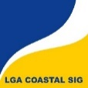
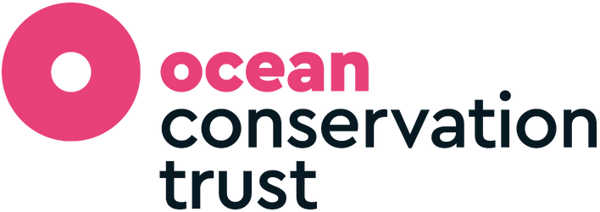
The Motion for the Ocean is supported in kind by the University of Exeter, LGA Coastal SIG, and the Ocean Conservation Trust.

